**Mux, Adder & Subtractor Using ModelSim**

**LAB # 10**



**Fall 2021**

**CSE304L Computer Organization & Architecture**

Submitted by: **Ashfaq Ahmad**

Registration No: **19PWCSE1795**

Class Section: **B**

Student Signature: ______________

Submitted to:

**Prof: Ammad khalil**

February 14, 2022

**Department of Computer Systems Engineering**

**University of Engineering and Technology, Peshawar**

**Objective:**

* To know how to implement Mux, Adder and subtractor using verilog HDL.

**Task01: implement 4x1 Multiplexer.**

**Logic Code:**

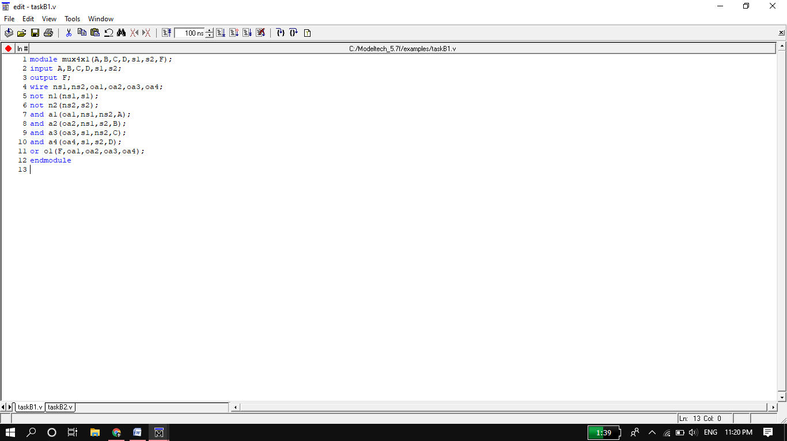

**Test bench file:**

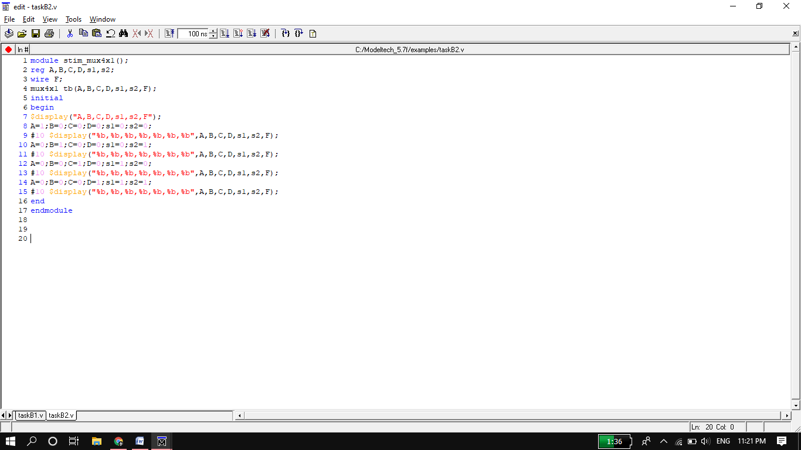

**Wave Form output:**

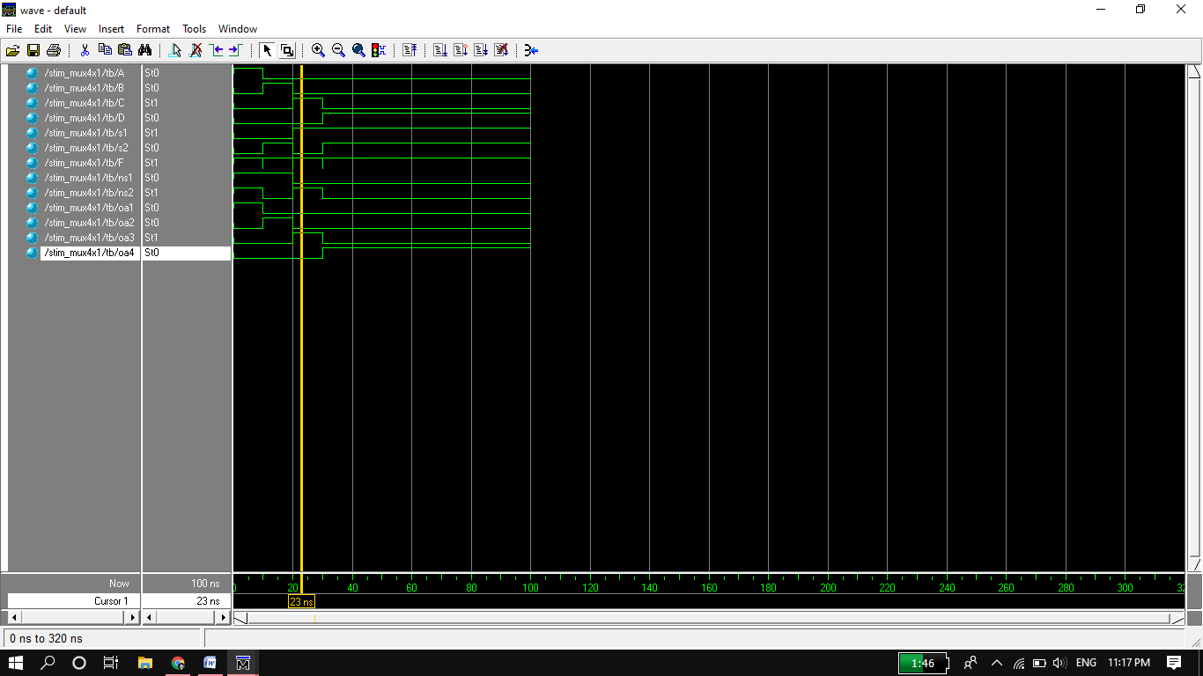

**Circuit:**

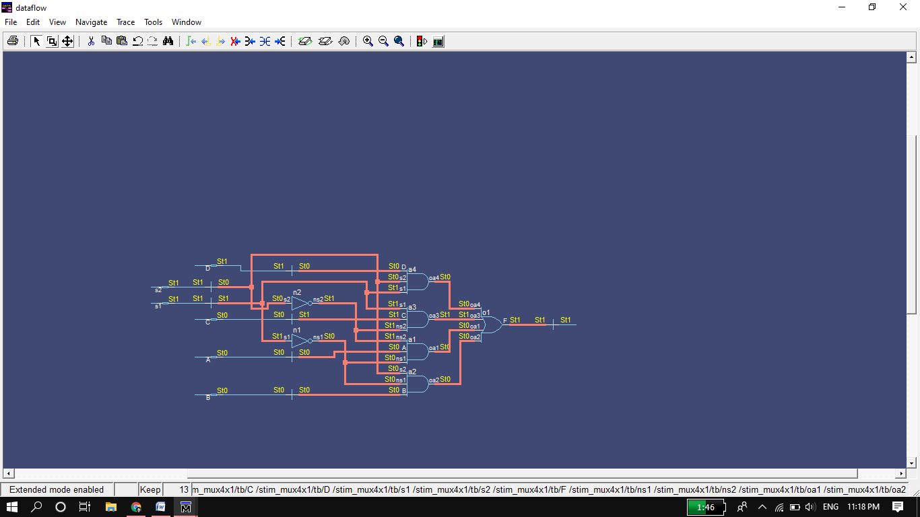

**Task02: implement 8x1 Multiplexer.**

**Logic Code:**

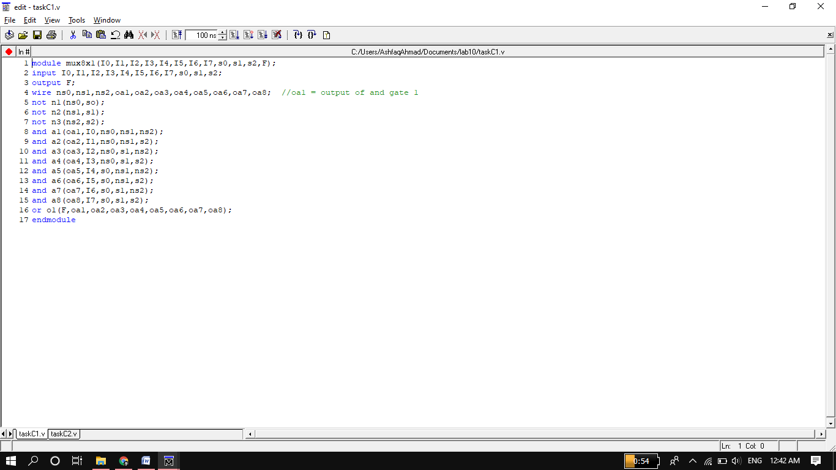

**Test bench file:**

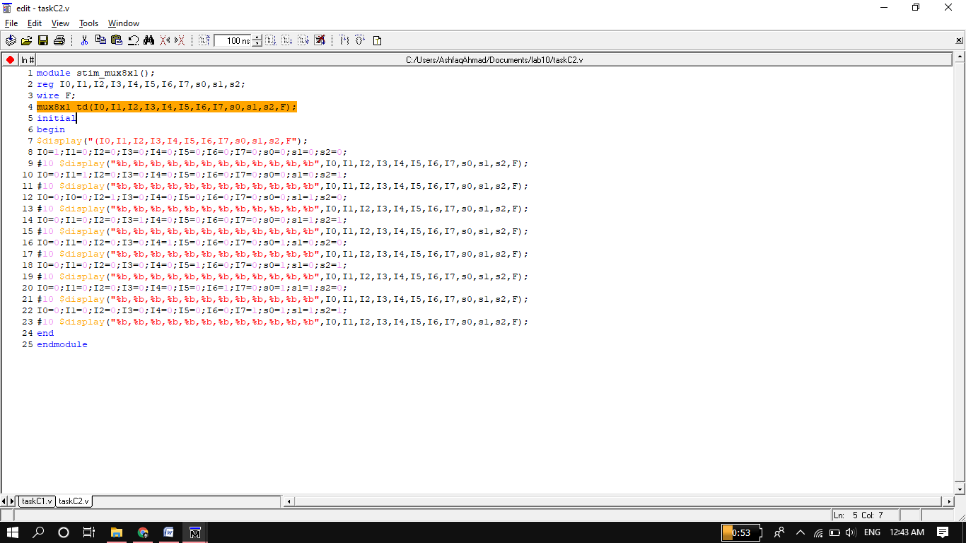

**Wave Form output:**

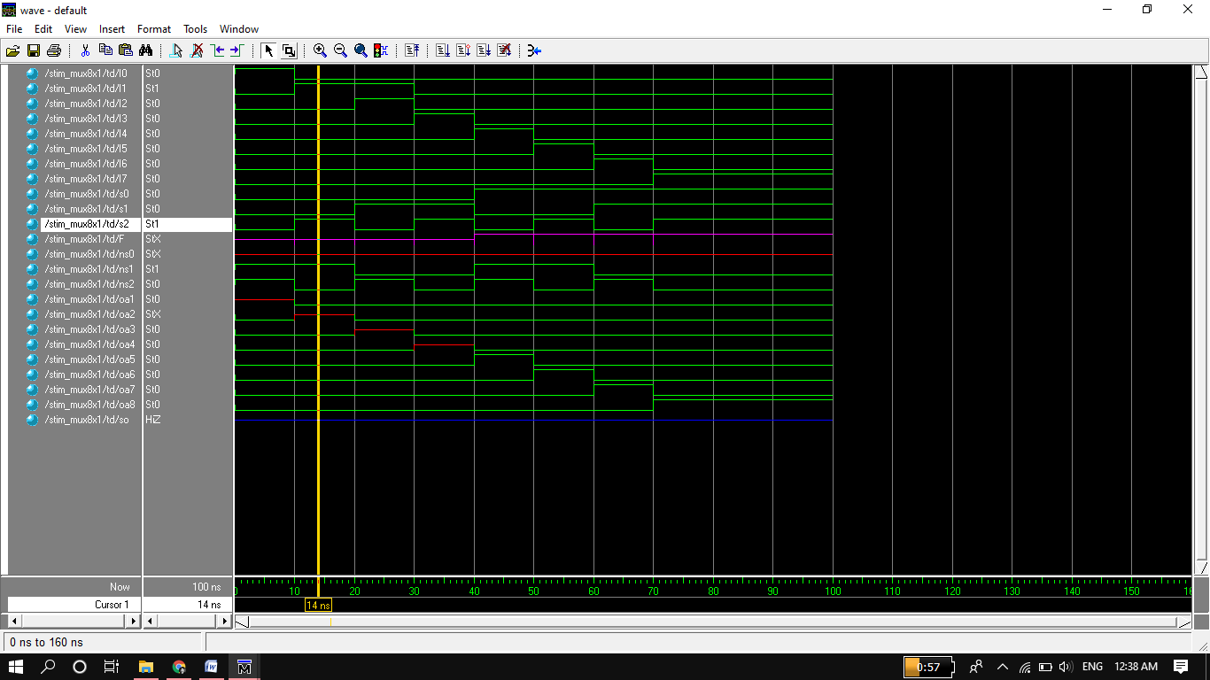

**Circuit:**

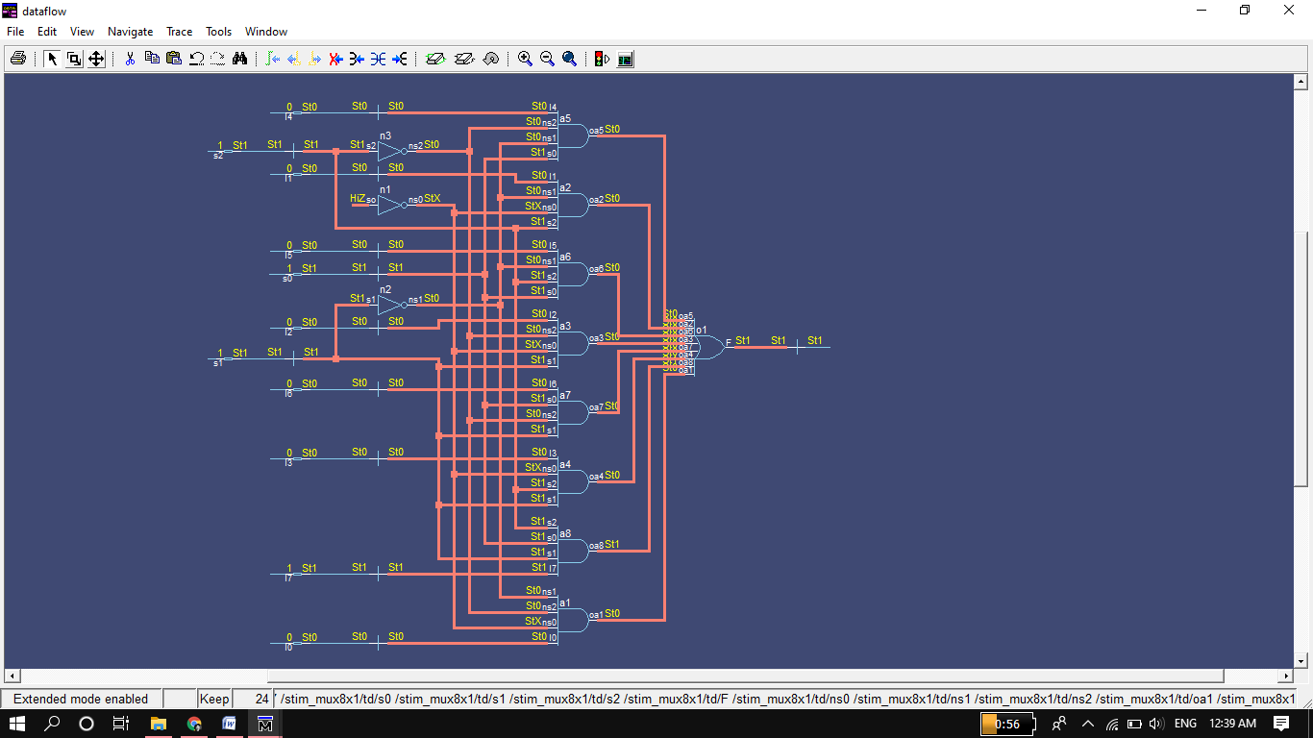

**Task03: Half Adder.**

**Logic Code:**

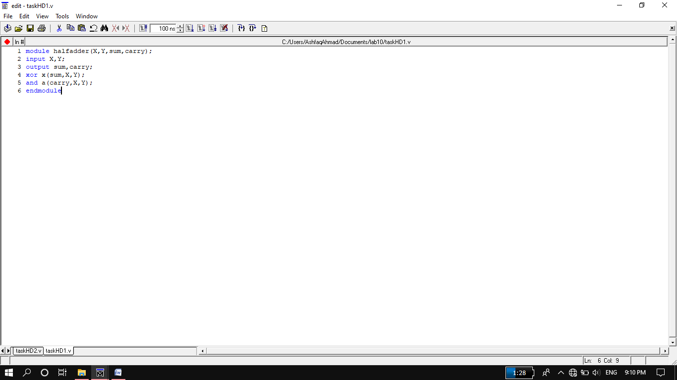

**Test bench file:**

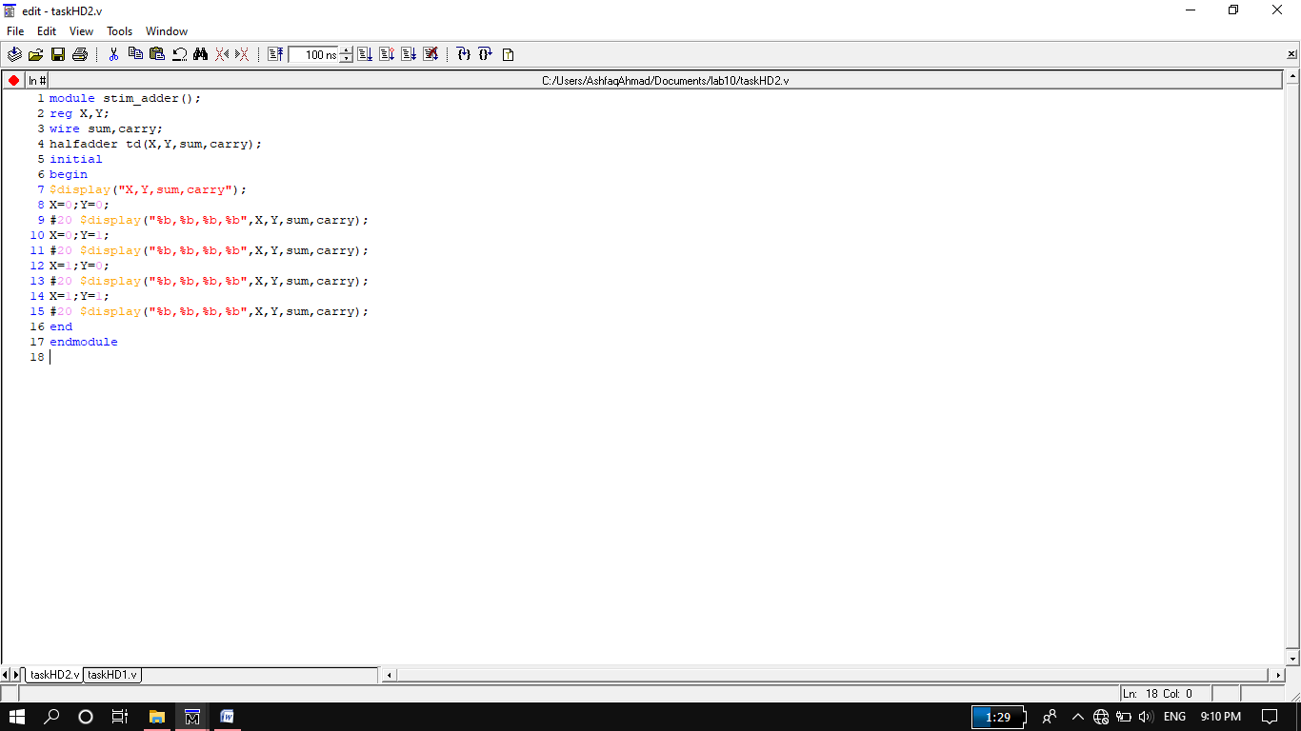

**Wave Form output:**

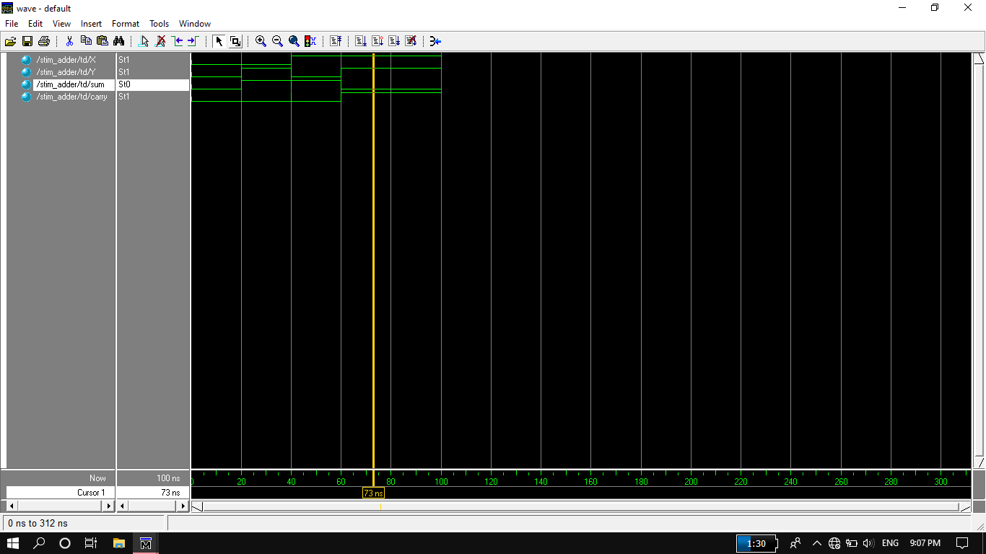

**Circuit:**

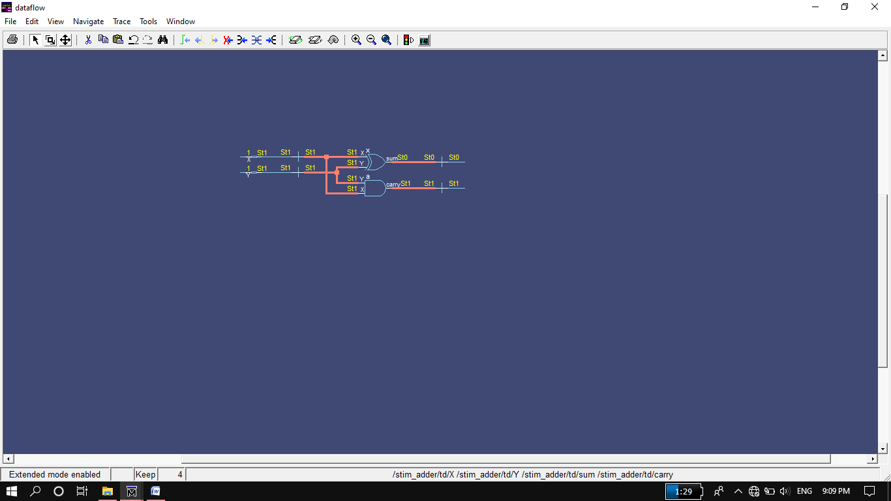

**Task04: implement Half Subtractor.**

**Logic Code:**

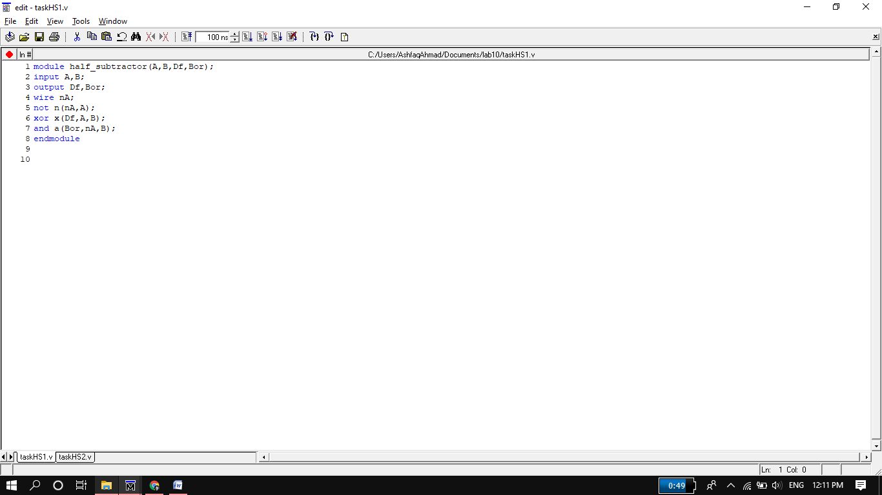

**Test bench file:**

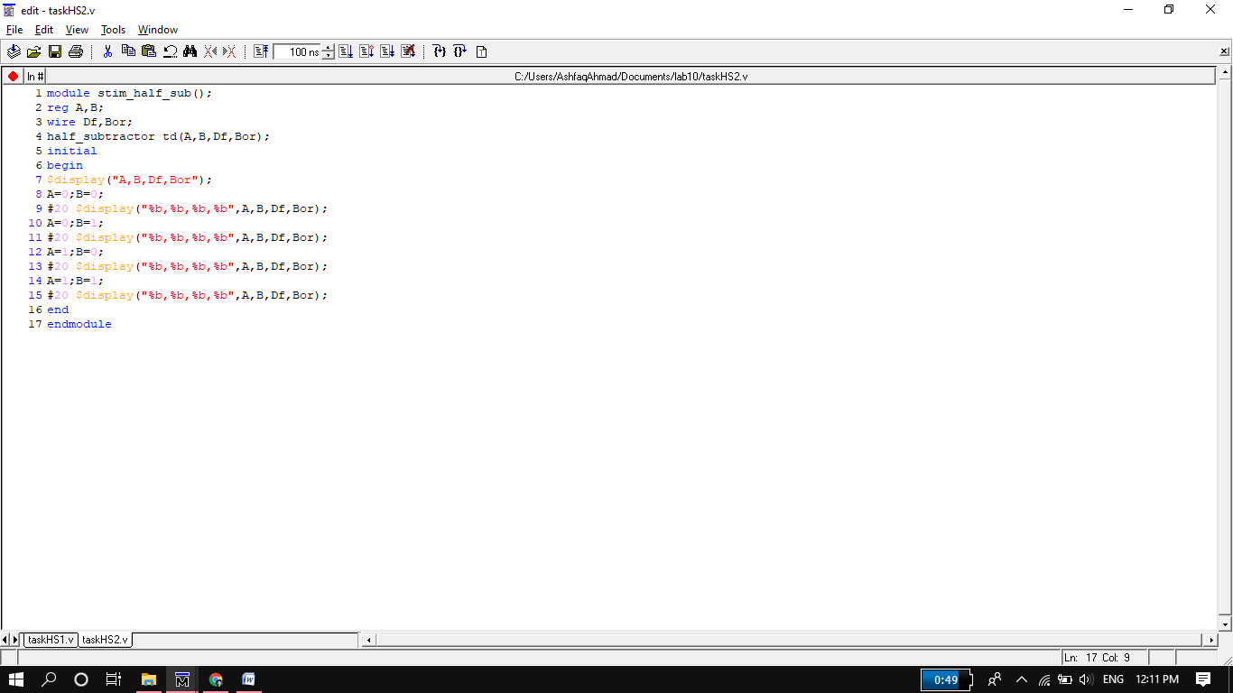

**Wave Form output:**

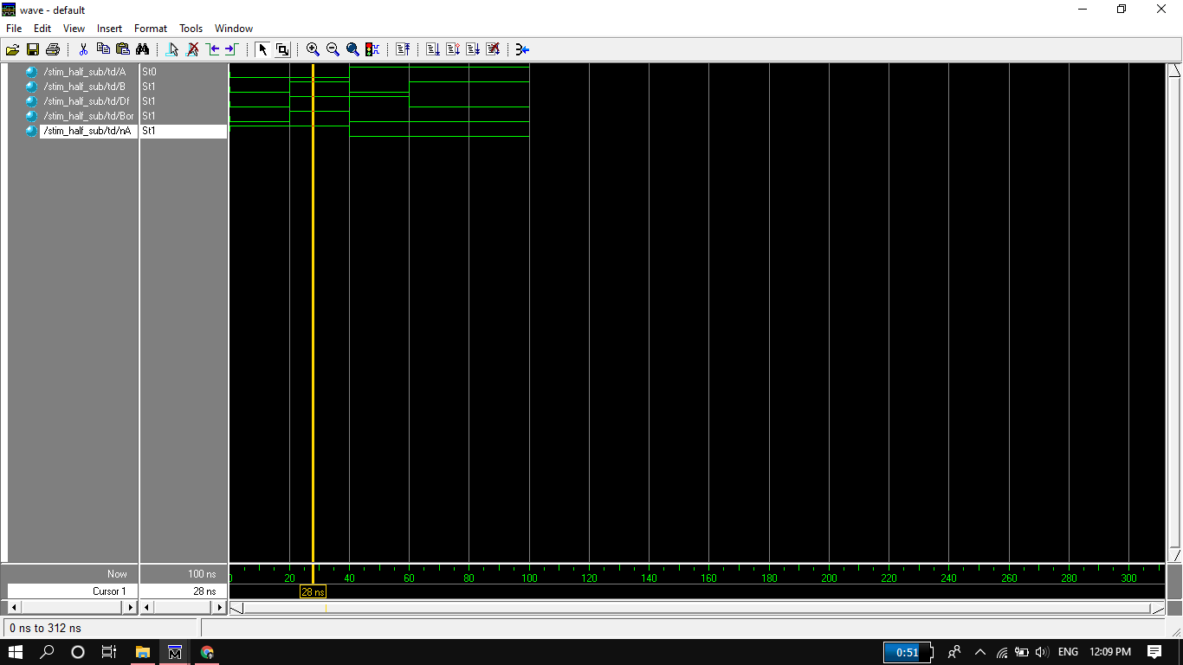

**Circuit:**

